**Lab 18: Simple EXE Hacking with Immunity**

**Course Name**: Malware Analysis and Reverse Engineering (IAM302)

**Student Name**: Nguyễn Trần Vinh – SE160258

**Instructor Name**: Mai Hoàng Đỉnh

**Lab Due Date**: 22/3/2023

**What You Need**

A Windows machine, real or virtual. I used a Windows Server 2008 virtual machine.

**Purpose**

To modify a Windows EXE file and save an altered version. This gives you practice with very simple features of the Immunity debugger.

**Task 1: Target EXE Recon**

**Get Immunity**

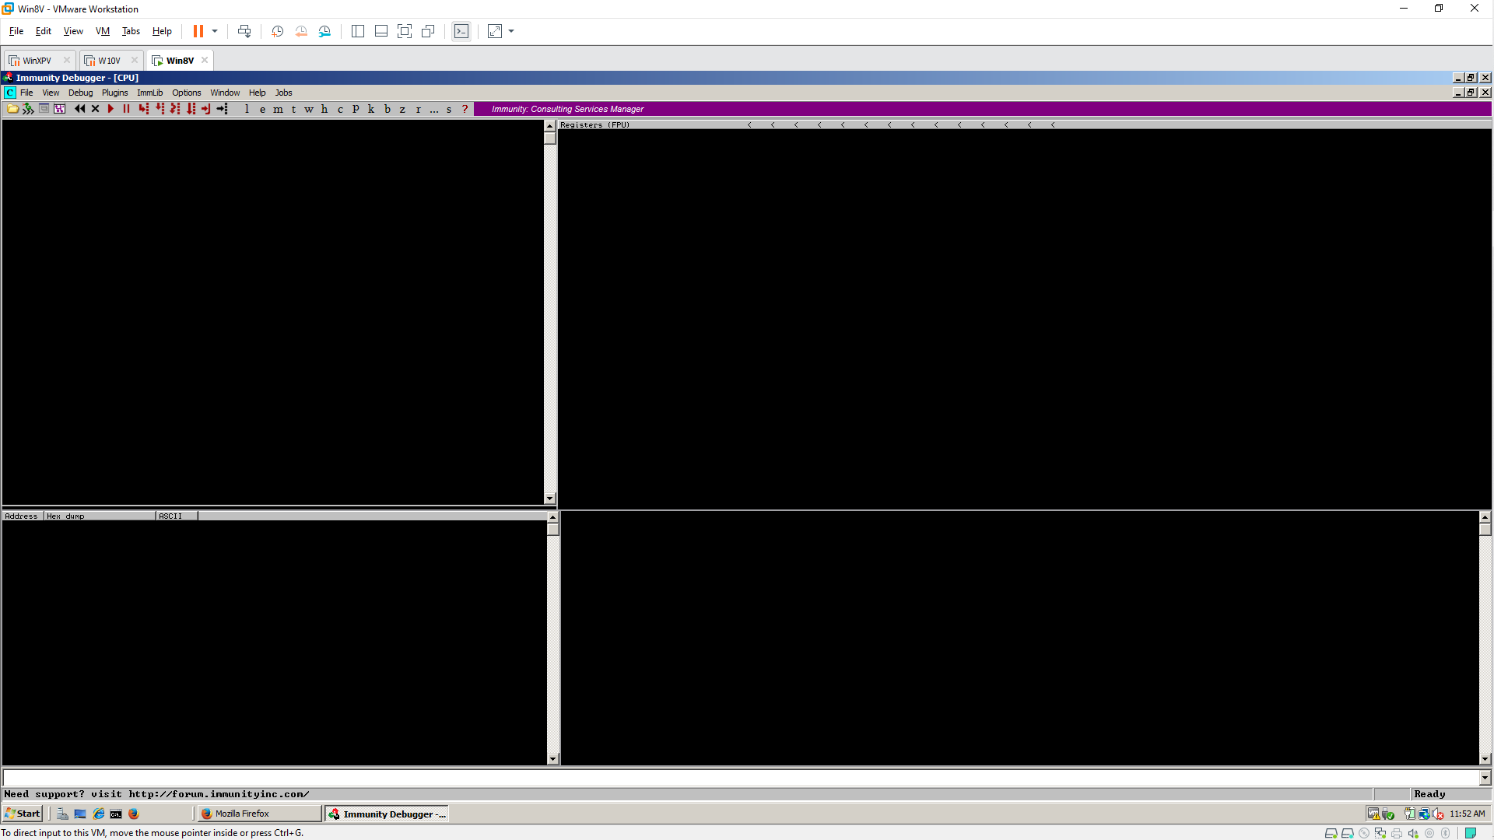

**Get putty.exe**

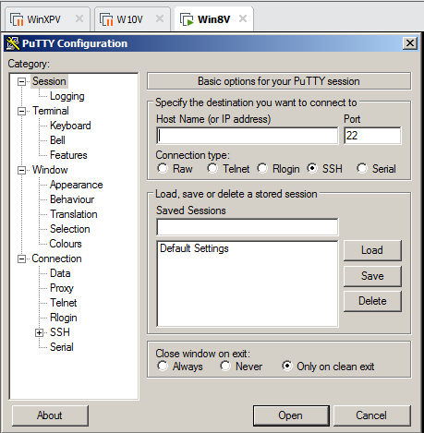 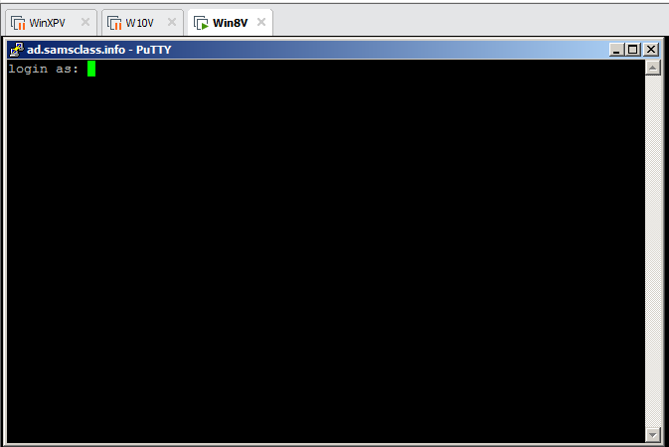

**Starting the Immunity Debugger**

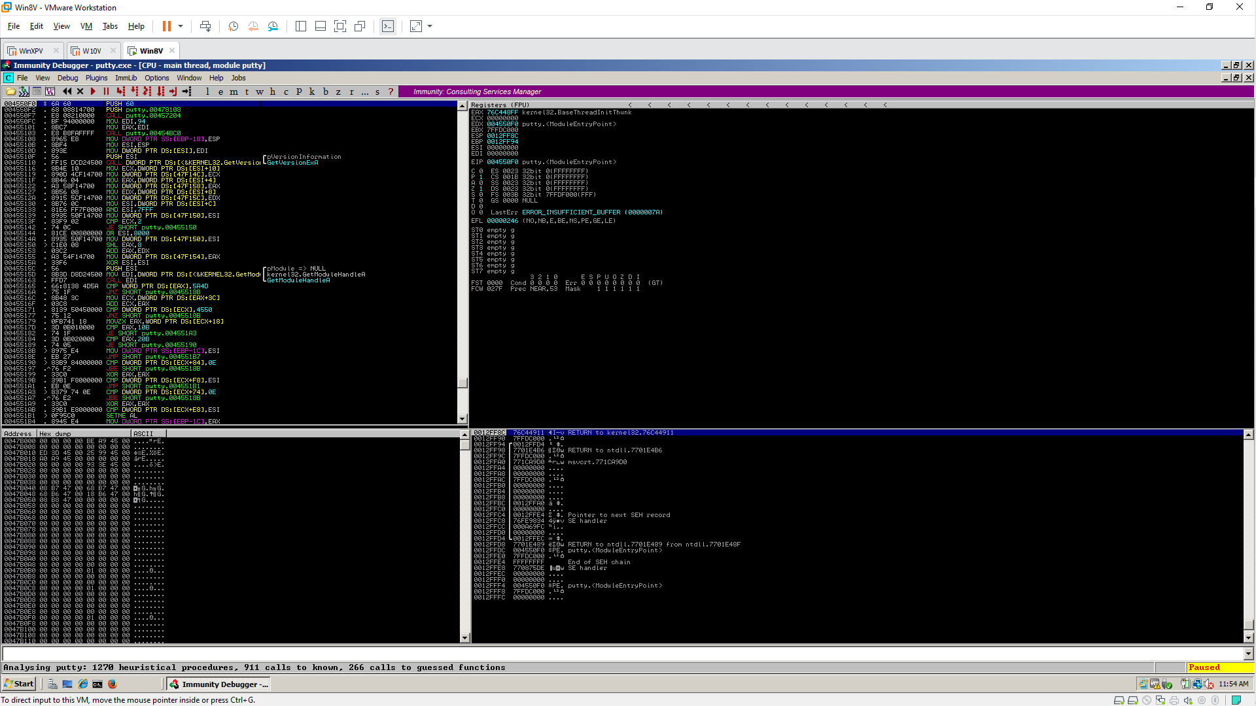

**Running Putty in Immunity**

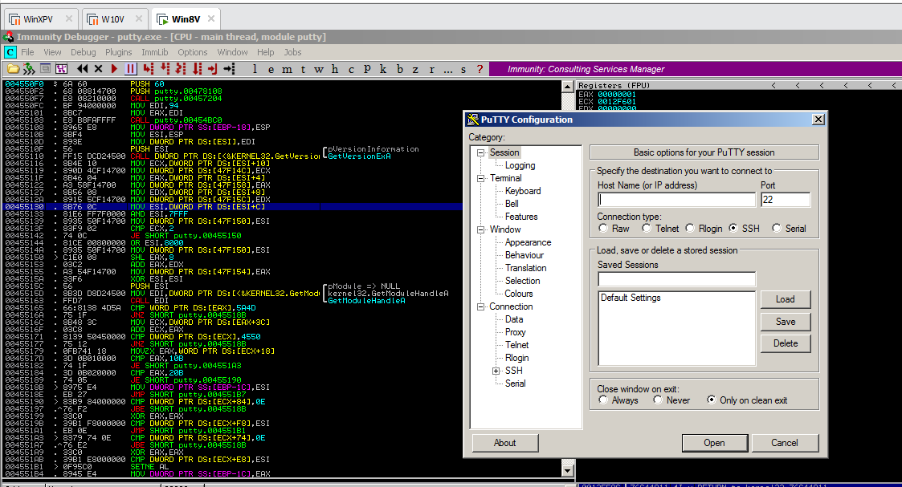 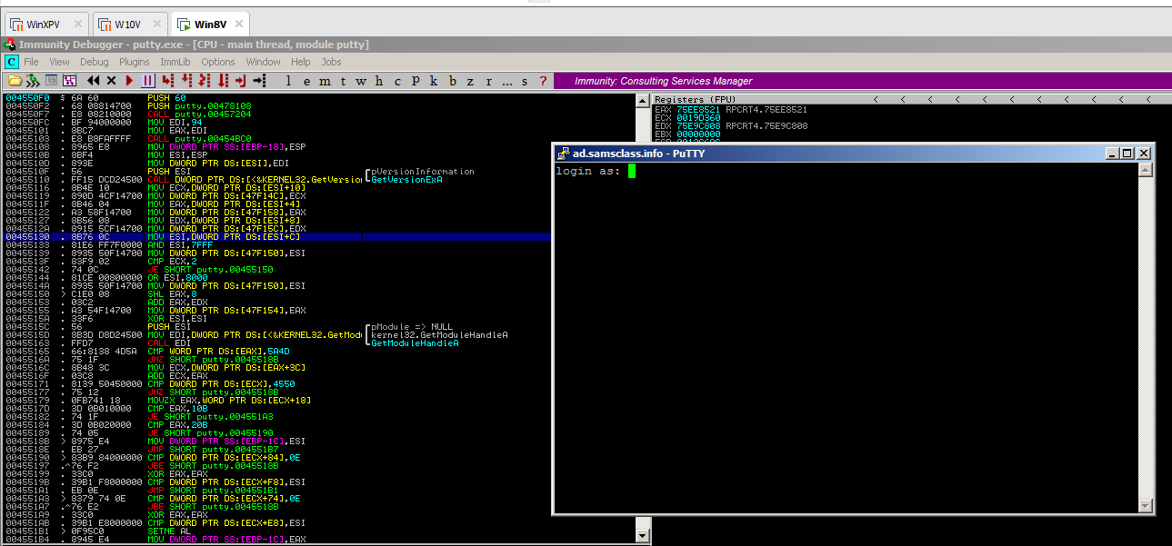

**Finding the "login as" Code**

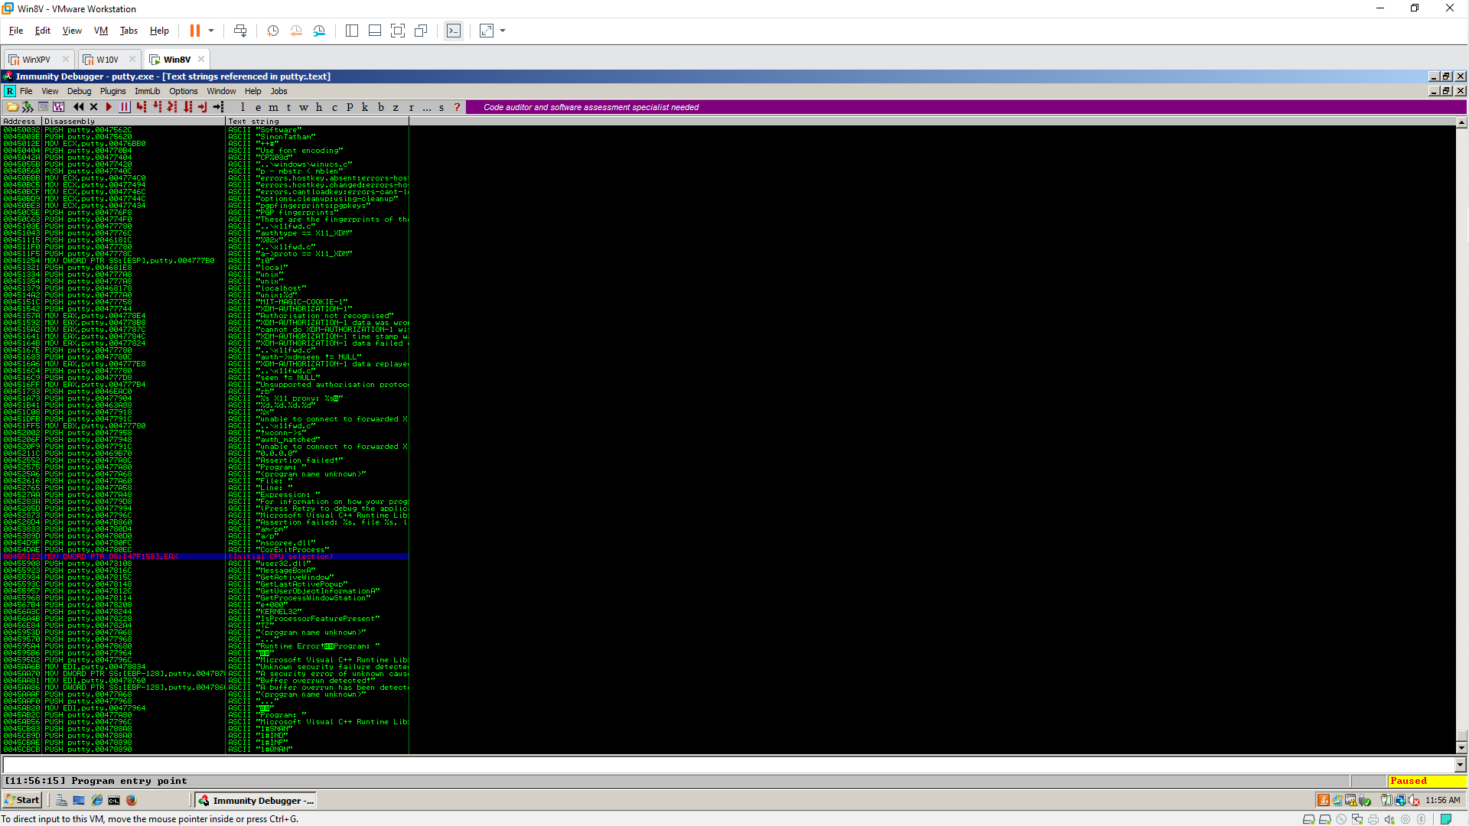

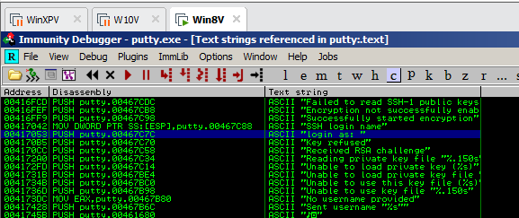 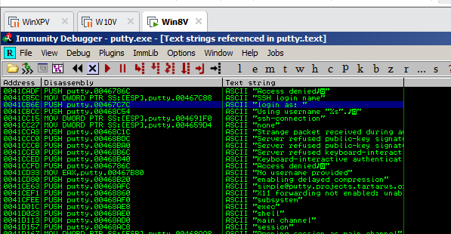

**Using Breakpoints**

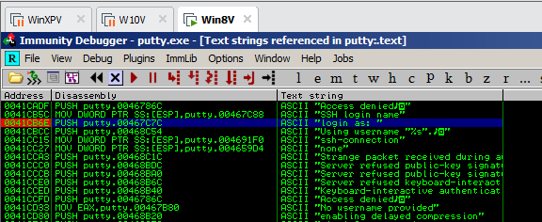 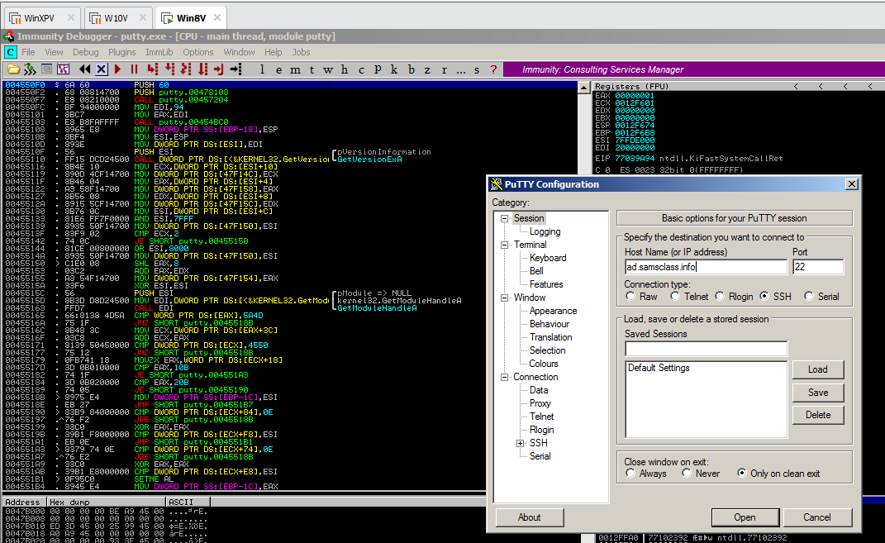 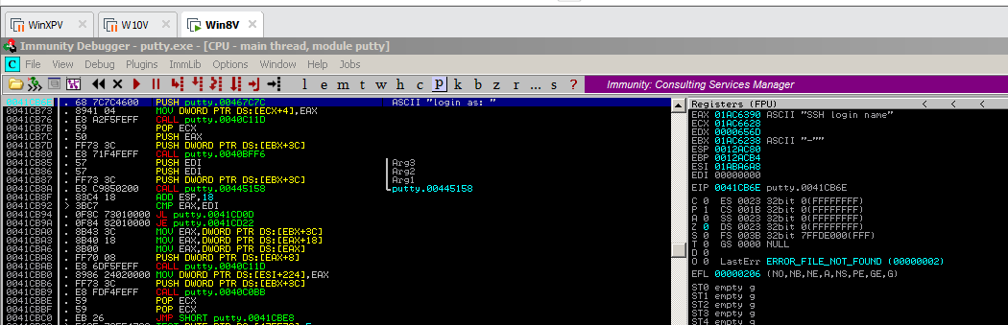

**Task 2: Alter the Login Message**

**Removing the Breakpoint**

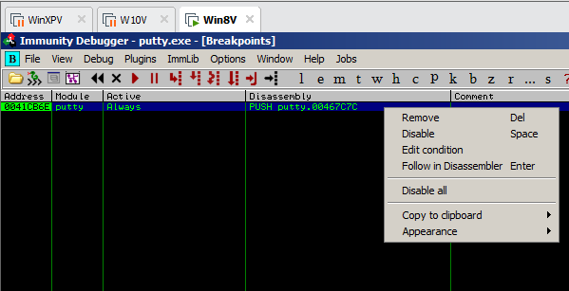 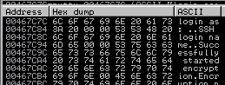

**Skipping the First Letter In the Message**

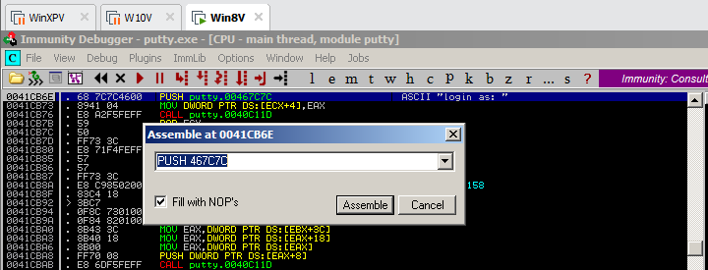 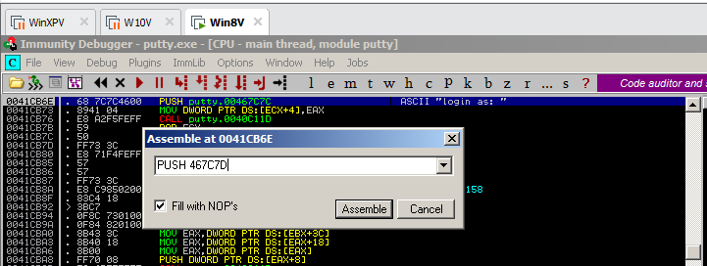 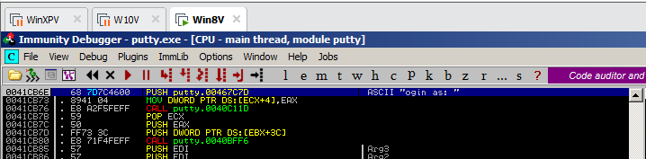

**Running the Modified Program**

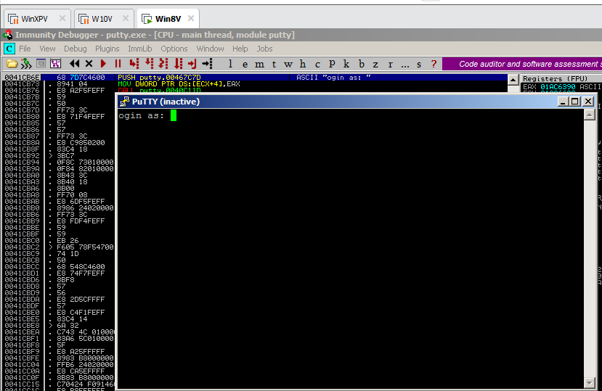

**Inserting Your Name**

